**JAYPEE INSTITUTE OF INFORMATION AND TECHNOLOGY NOIDA , SECTOR 62**



**TOPIC:** INTELLIGENT TRAFFIC SENSING

**SUBMITTED BY:**

**BATCH: B10**

|  |  |
| --- | --- |
| **SHIVANG MISHRA:** | **22103275** |
| **VANSHIKA AGARWAL:** | **22103276** |
| **PRARABDH AGARWAL:** | **22103280** |
|  |  |

**SUBMITTED TO:**

**SHERRY GARG**

**PROBLEM STATEMENT:**

Develop a Intelligent Traffic System aimed at optimizing the efficiency of traffic movement in a city, enhancing commuter experience, and facilitating seamless roadways management. The system should address key challenges in inside city transportation, providing solutions for route planning, traffic management, and overall operational optimization.

### MOTIVATION:

Urban areas across the globe are facing a mounting challenge of traffic congestion, which not only leads to wasted time and increased fuel consumption but also exacerbates environmental pollution levels. As roads become more congested, commuters spend significant amounts of time stuck in traffic, leading to decreased productivity and heightened stress levels. Moreover, the increased fuel consumption associated with congestion contributes to higher greenhouse gas emissions, exacerbating climate change and air quality issues.

To address these pressing challenges, the development of an Intelligent Traffic System (ITS) becomes imperative. By harnessing the power of technology, an ITS can revolutionize the way traffic flow is managed within urban environments. Through real-time data analysis and predictive algorithms, the system can optimize traffic signal timings, dynamically adjust routes, and integrate public transportation options seamlessly. This not only reduces congestion on roads but also enhances the overall commuter experience by providing efficient and reliable travel options.

Furthermore, the motivation behind developing an ITS extends beyond mere convenience. It is driven by a broader aspiration to create cities that are not only more livable and efficient but also environmentally sustainable. By promoting alternative modes of transportation, such as public transit and cycling, an ITS encourages a shift away from reliance on single-occupancy vehicles, thereby reducing traffic congestion and carbon emissions. Additionally, by optimizing traffic flow and reducing idling time, the system contributes to improved air quality and mitigates the adverse environmental impacts associated with vehicular pollution.

**OBJECTIVE:**

* **Reducing Congestion:** The intelligent traffic management system aims to alleviate traffic congestion within urban areas by implementing advanced algorithms and real-time data analysis to optimize traffic flow and reduce bottlenecks.
* **Minimizing Travel Time:** One of the key objectives is to minimize travel time for commuters by providing them with dynamically optimized routes based on current traffic conditions and historical data. By guiding drivers along the most efficient paths, the system aims to enhance overall travel efficiency and reduce delays.
* **Mitigating Environmental Impact**: The system is designed to contribute to environmental sustainability by reducing vehicular emissions and mitigating the overall environmental impact of traffic congestion. By promoting smoother traffic flow and reducing idling time, the system helps minimize air pollution and carbon emissions.
* **Enhancing Traffic Efficiency**: Through the integration of advanced technologies such as machine learning and dynamic traffic signal control, the system seeks to enhance overall traffic efficiency. By adapting traffic signal timings in real-time and optimizing public transportation schedules, the system aims to streamline the movement of vehicles and improve overall traffic management.
* **Revolutionizing Urban Mobility:** The overarching objective is to revolutionize urban mobility and transportation management by leveraging cutting-edge technologies. By integrating machine learning, dynamic traffic signal control, route optimization, and public transportation integration, the system aims to usher in a new era of intelligent transportation systems that prioritize efficiency, sustainability, and the overall commuter experience.

**REQUIREMENTS SPECIFICATIONS:**

The system should collect and analyze diverse data sources, including historical traffic data, weather conditions, and real-time traffic information.

It must incorporate machine learning algorithms for predicting traffic flow and optimizing traffic signal timings dynamically.

Route optimization features should utilize algorithms such as Dijkstra's or A* for efficient route planning based on current traffic conditions and historical data.

Integration with public transportation systems should provide real-time updates, optimize schedules, and facilitate seamless connectivity between private and public transportation modes.

The system must ensure data privacy and security, comply with regulations, and address privacy concerns related to the collection and storage of user data.

A user-friendly interface, including a mobile application, should provide real-time traffic updates, route recommendations, and public transportation information, catering to diverse user needs and preferences.

**KEY FEATURES:**

**Traffic Flow Prediction**:

Utilize historical traffic data, weather conditions, and special events information to predict future traffic conditions.

Implement machine learning algorithms for real-time traffic flow prediction.

Dynamic Traffic Signal Control:

Design an adaptive traffic signal control system that adjusts signal timings based on real-time traffic conditions.

Utilize reinforcement learning to optimize traffic signal timings dynamically.

Route Optimization and Recommendation:

Develop a system that recommends the most efficient routes to drivers based on current traffic conditions and historical data.

Implement algorithms such as Dijkstra's or A* for route planning.

**Public Transportation Integration**

Integrate real-time public transportation data into the system to provide seamless connectivity between private and public transportation.

Optimize bus and train schedules dynamically based on demand.

**Traffic Violation Detection:**

Integrate surveillance cameras and computer vision techniques to detect traffic violations, such as running red lights or illegal U-turns.Implement a notification system for law enforcement.

**Environmental Impact Assessment:**

Evaluate the environmental impact of traffic congestion and propose strategies to reduce emissions and promote eco-friendly transportation options.

Integrate environmental data into the decision-making process.

**User-Friendly Interface:**

Create a user-friendly mobile application that provides real-time traffic updates, route recommendations, and public transportation information.

Implement features such as voice-based navigation and community-driven reporting of road conditions.

**Data Privacy and Security:**

Address privacy concerns by implementing secure data transmission and storage practices. Ensure compliance with data protection regulations.

**Community Engagement:**

Develop a platform for community engagement, allowing residents to provide feedback, report issues, and participate in decision-making processes related to traffic management.

**LITERATURE RELATED TO ALGORITHM USED:**

The system incorporates various algorithms, including:

Dijkstra's Algorithm: For finding the shortest path and optimizing route planning.

Greedy Technique: Employed to make efficient decisions in real-time traffic management.

Floyd- Warshall Algorithm: Explored in research for its application in traffic network analysis, especially for finding the shortest paths between all pairs of nodes in a weighted graph, which is beneficial for overall traffic flow optimization.

Edmonds-Karp Algorithm: Studied in the context of traffic flow optimization and network flow problems, particularly for its application in finding the maximum flow in a flow network, which can be relevant in traffic management scenarios such as congestion control and route planning.

Dynamic Programming: Used for optimizing traffic flow and managing complex routing scenarios.

Prim's Algorithm: Studied in the context of traffic network optimization for its application in finding the minimum spanning tree of a connected, undirected graph. This algorithm can be relevant in optimizing traffic signal control and network design for efficient traffic flow.

**USE CASE DIAGRAM:**

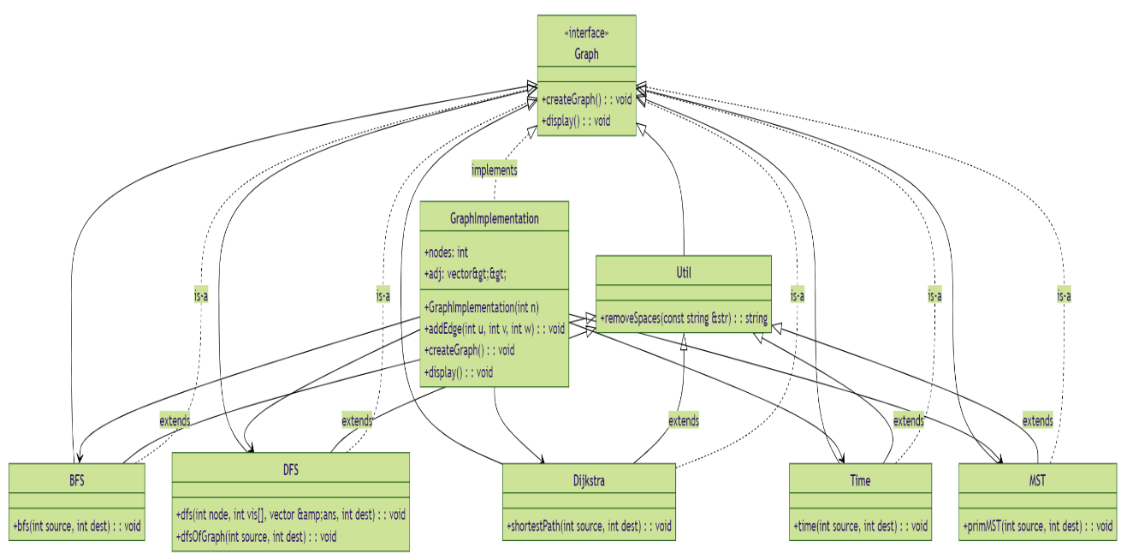

**DATA FLOW DIAGRAM:**

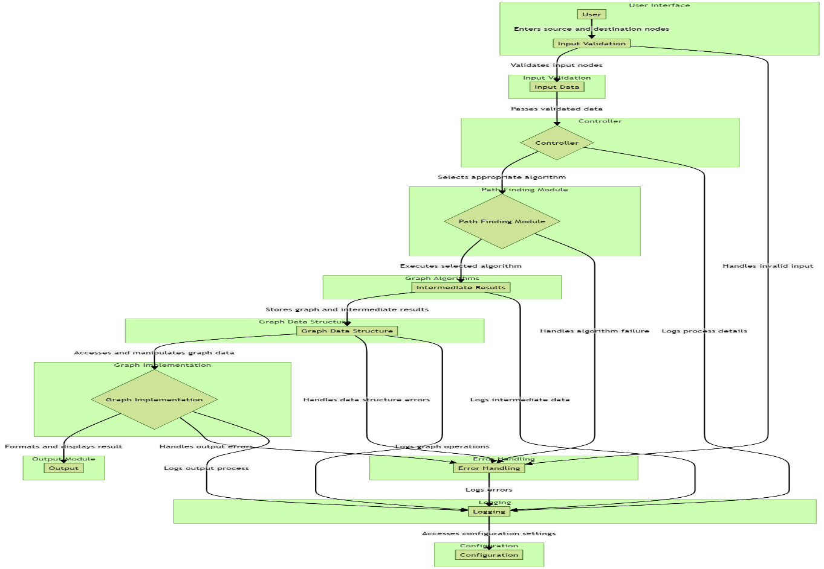

**IMPLEMENTATION USING MAIN MODULE:**

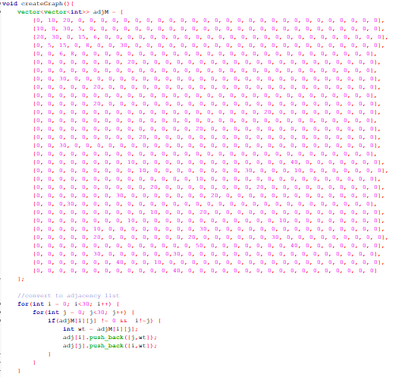

**createGraph()**:

* + This function is responsible for initializing the graph data structure based on the provided data.
  + It sets up the adjacency lists representing the graph where each node is represented as an integer, and each edge is represented as a pair of integers (destination node, edge weight).
  + The graph can be either directed or undirected based on the problem requirements.

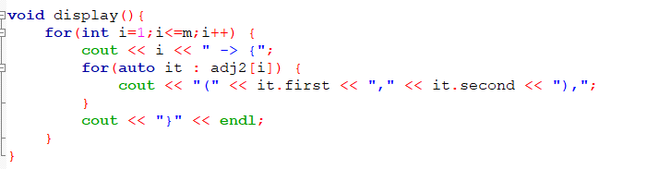

**display()**:

* + This function is used for visualizing the graph.
  + It prints the adjacency lists to the console, showing the connections between nodes and their corresponding weights.

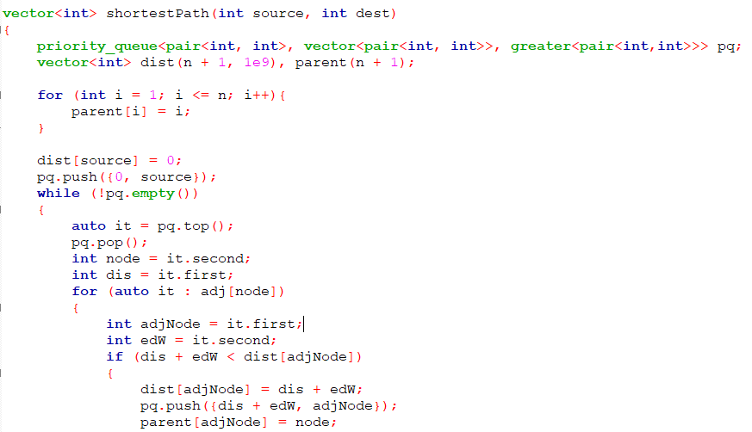

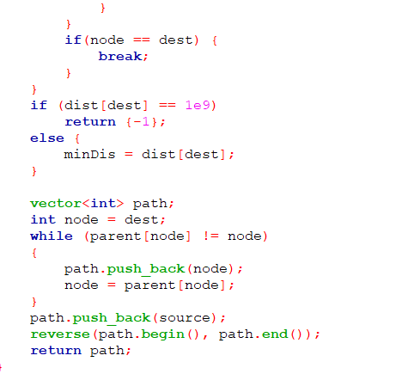

**shortestPath(int source, int dest)**:

* + This module calculates the shortest path from a given source node to a destination node using Dijkstra's algorithm.
  + It takes the source and destination nodes as input parameters and returns a vector representing the shortest path.
  + Dijkstra's algorithm finds the shortest path by maintaining a priority queue of nodes to be visited next and continually updating the shortest distances from the source node to all other nodes.

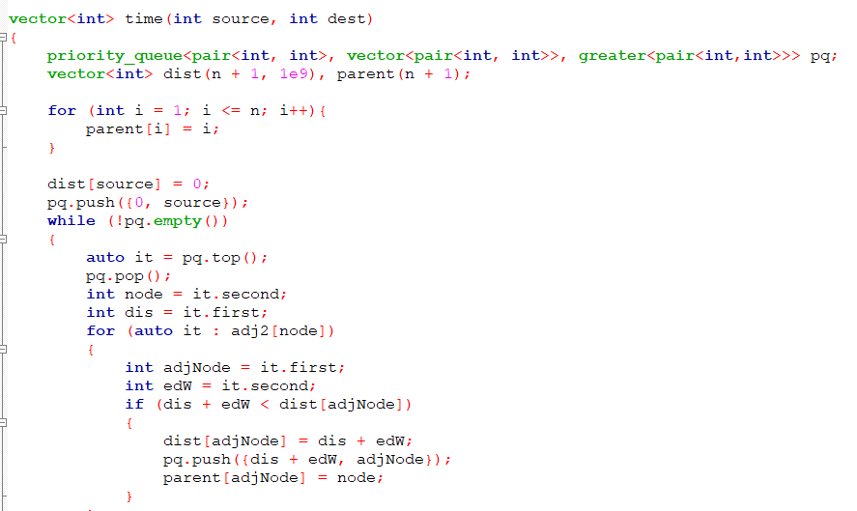

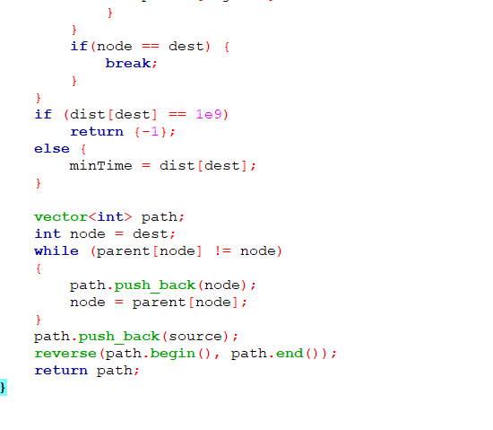

**time(int source, int dest)**:

* + This module calculates the travel time from a given source node to a destination node, considering road blockages.
  + It is similar to the shortest path module but operates on a modified graph where certain edges may be blocked or have increased weights.
  + The modified graph accounts for possible road blockages or delays and adjusts the shortest path accordingly.

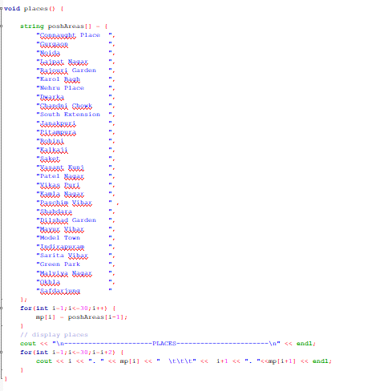

**places()**:

* + This module displays available places to visit.
  + It could involve simply printing a list of places stored in a data structure or retrieving information from an external database.
  + The places could be represented as strings or any other suitable data type depending on the application.

**TEST CASE IMPLEMENTING EACH FUNCTION:**

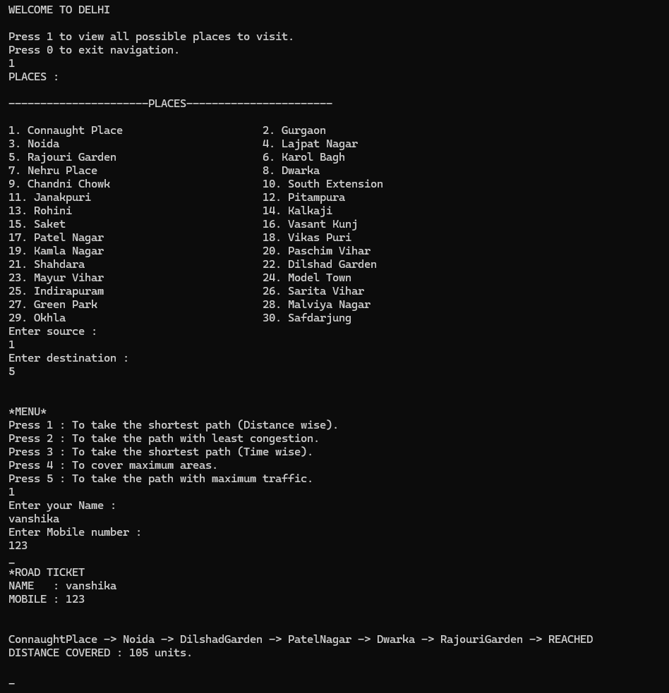

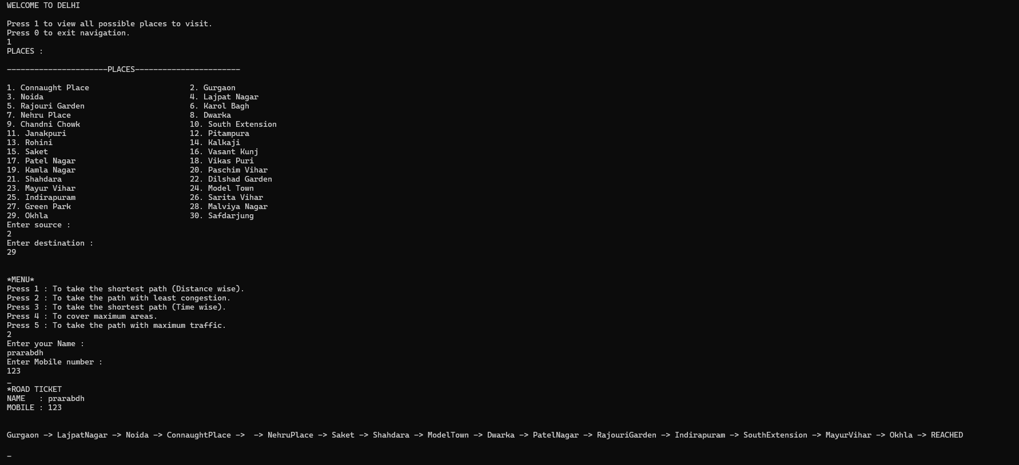

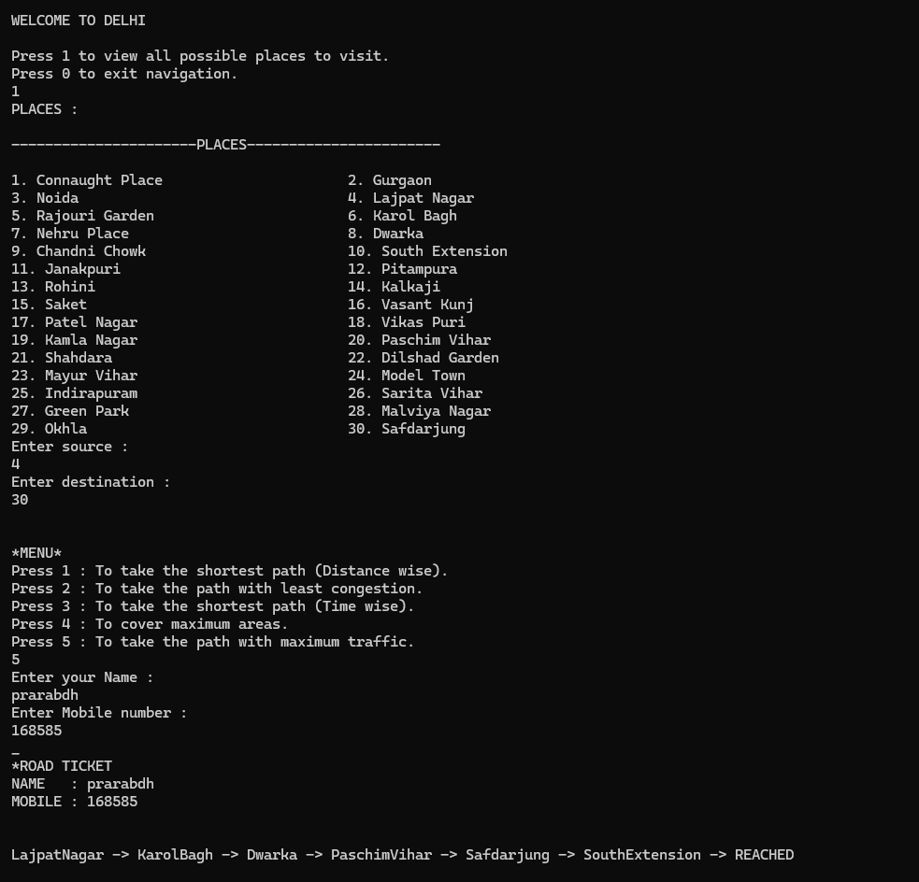

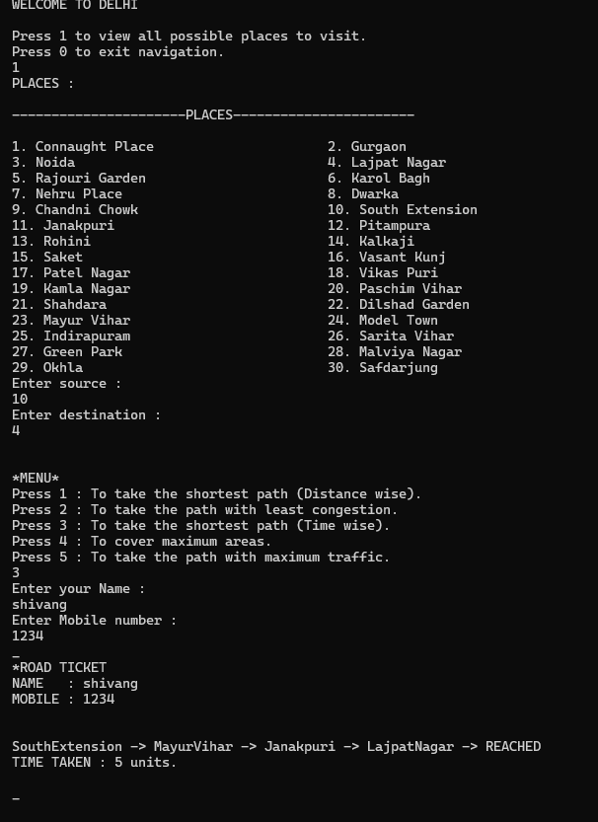

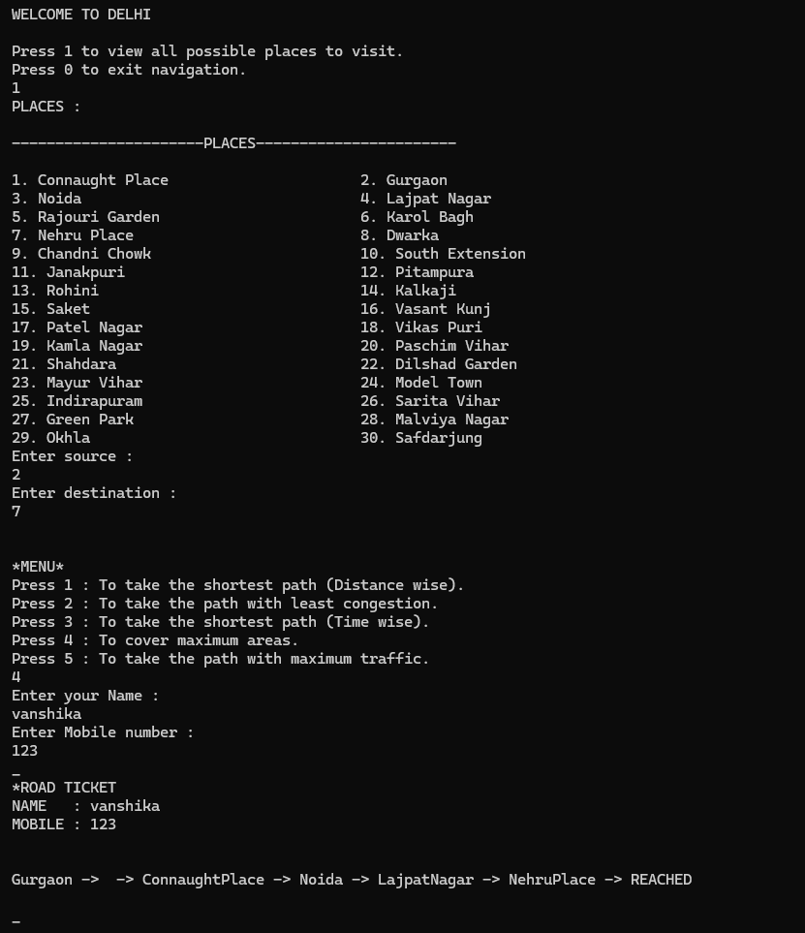

**RESULT:**

* Improved Traffic Flow: Through the implementation of dynamic traffic signal control and route optimization algorithms, the system effectively manages traffic flow within the city. By dynamically adjusting signal timings based on real-time traffic conditions and recommending the most efficient routes to drivers, the system ensures smoother traffic movement and reduced congestion at key intersections and road segments.
* Reduced Congestion: By predicting traffic flow patterns and dynamically optimizing traffic signals, the system significantly reduces congestion at peak hours and bottleneck areas. This leads to smoother traffic flow along major routes and minimizes the occurrence of traffic jams, thereby improving overall traffic conditions across the city.
* Decreased Travel Time for Commuters: Commuters experience shorter travel times due to the system's ability to recommend optimal routes based on real-time traffic conditions. By leveraging historical data and predictive analytics, the system identifies the fastest and least congested routes for commuters, allowing them to reach their destinations more efficiently and with minimal delays.
* Enhanced Emergency Response Times: The system's real-time traffic updates and dynamic routing capabilities contribute to faster emergency response times. Emergency vehicles are guided through the most efficient routes, bypassing congested areas and minimizing response delays. This ensures timely assistance during emergencies, potentially saving lives and mitigating property damage.

Smoother Commuting Experience: The integration of real-time traffic updates, route recommendations, and public transportation information into a user-friendly mobile application enhances the overall commuting experience for residents. Commuters can access up-to-date information on traffic conditions, plan their routes more effectively, and seamlessly transition between private and public transportation options. Voice-based navigation further simplifies the commuting process, making it more convenient and user-friendly.

Overall, the system's implementation results in a noticeable improvement in traffic flow, congestion reduction, decreased travel time for commuters, and enhanced emergency response times, ultimately contributing to a smoother and more efficient transportation system within the city.

**CONCLUSION AND FUTURE SCOPE:**

The Intelligent Traffic System represents a significant step forward in addressing the complex challenges associated with urban traffic management. By harnessing advanced technologies and methodologies, the system offers a comprehensive solution aimed at optimizing traffic flow, reducing congestion, and enhancing the overall commuter experience. Through the integration of machine learning algorithms, dynamic traffic signal control, route optimization, and public transportation integration, the system demonstrates its capability to revolutionize urban mobility and transportation management.

While the current iteration of the Intelligent Traffic System provides substantial benefits, there are several avenues for future enhancements and expansion:

1. Integration with Autonomous Vehicles: As autonomous vehicle technology continues to evolve, integrating these vehicles into the traffic management system could further optimize traffic flow and enhance safety. Future iterations of the system could incorporate features to support communication and coordination with autonomous vehicles, allowing for seamless integration into existing traffic patterns.

2. Enhanced Predictive Analytics: By leveraging advanced data analytics and predictive modeling techniques, the system can anticipate traffic patterns and congestion hotspots more accurately. This would enable proactive measures to be taken to mitigate congestion before it occurs, leading to even greater improvements in traffic flow and efficiency.

3. Community Engagement Initiatives: Broadening community engagement initiatives can foster greater public participation in traffic management processes. By involving residents in decision-making processes, collecting feedback, and encouraging collaboration, the system can better address the unique needs and preferences of the local community, ultimately leading to more effective traffic management strategies.

4. Environmental Impact Mitigation: Expanding the system's focus to include environmental impact mitigation strategies can further promote sustainable transportation solutions. By evaluating the environmental footprint of traffic congestion and implementing measures to reduce emissions, such as promoting eco-friendly transportation options and optimizing traffic patterns, the system can contribute to a cleaner and healthier urban environment.

5. Scalability and Adaptability: As cities continue to grow and evolve, the Intelligent Traffic System should remain scalable and adaptable to accommodate changing infrastructure and traffic patterns. Future enhancements should focus on ensuring that the system can seamlessly integrate with emerging technologies and scale to meet the evolving needs of urban environments.

In conclusion, while the current version of the Intelligent Traffic System represents a significant advancement in urban traffic management, there is considerable scope for future enhancements and expansion. By embracing emerging technologies, fostering community engagement, and prioritizing sustainability, the system can continue to evolve and address the complex challenges of urban mobility in an increasingly dynamic world.

**REFERENCES:**

<https://www.freeprojectz.com/c-projects-projects>

<https://www.javatpoint.com/dijkstras-algorithm>

https://[www.freecodecamp.org/news/dijkstras-shortest-path-algorithm-visual-](http://www.freecodecamp.org/news/dijkstras-shortest-path-algorithm-visual-) introduction/

https://[www.filipekberg.se/2012/05/02/creating-a-windows-](http://www.filipekberg.se/2012/05/02/creating-a-windows-)in-c/

https://courses.lumenlearning.com/waymakermath4libarts/chapter/shortest- path/